Violin plots showing coefficients of variation on the y-axis calculated for each species under each kmixing and normalized against each years’ coefficient of variation for offshore phytoplankton. Combined results for 2001, 2003, and 2006.

kmixing = 0.1 hr-1

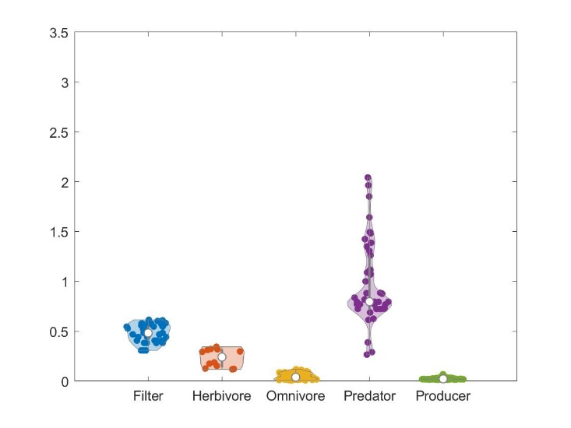kmixing = 1 hr-1

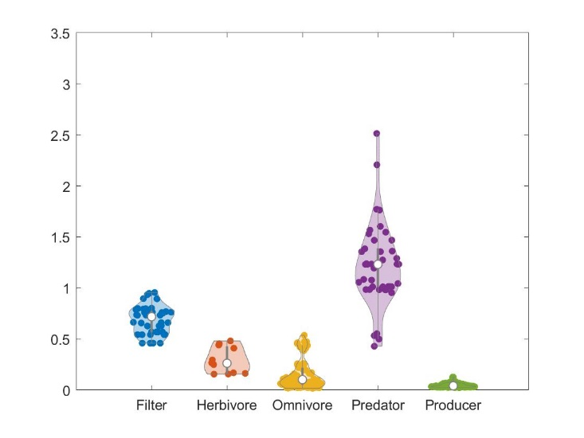 kmixing = 10 hr-1